Task 1. Quiz Arena
Core Concept
This is a component-based, event-driven frontend system that simulates real-time multiplayer communication — without a real backend.
Students will build:
- Lobby system
- Async question loader
- Countdown timer
- Leaderboard
- Custom event communication between modules
- Simulated external player updates
E.g App Structure:
/quiz-app
├── state.js
├── lobby.js
├── question.js
├── scoreboard.js
├── timer.js
├── app.js
Notes:
- Never manipulate DOM without updating state
- Never change state without reflecting in DOM
Requirements:
Lobby should include the player details
A count down timer for each question
If the question exceeds time set by timer proceed to next question
Questions can be random or asynchronous
Final score should be shown on leaderboard
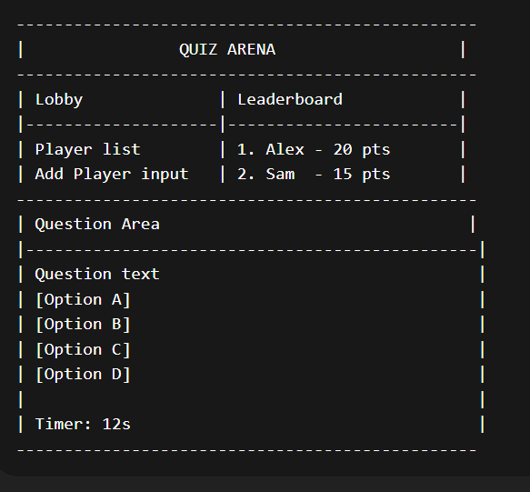

Task 2. Implement a tic-tac-toe game
Build a fully functional Tic Tac Toe game with:
- Clickable 3×3 grid
- Turn switching (X / O)
- Win detection
- Draw detection
- Reset functionality
- Clean DOM updates

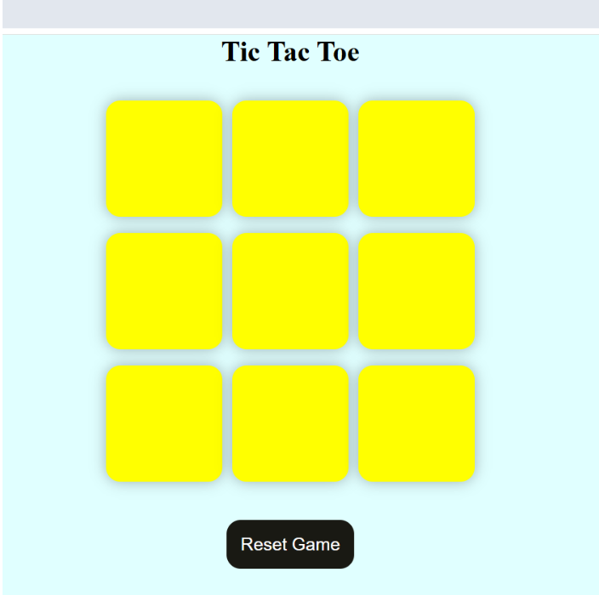

Task 3. Dynamic Visual Workflow Builder (Drag-Drop + Communication)
Build a visual automation system, similar to:
- Zapier
- Node-based editors
- Flow builders
User builds:
Trigger → Condition → Action
Each block is dynamic and interactive.
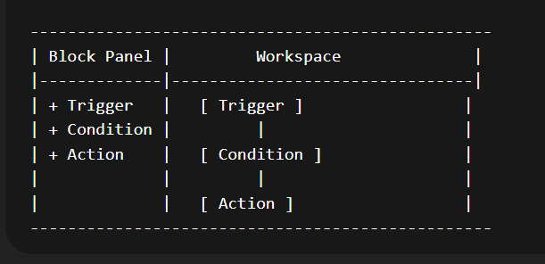
Left:
- Block creation panel
Right:
- Large drag-drop canvas
STEP 1 — Block Creation
User clicks:
- Add Trigger
- Add Condition
- Add Action
STEP 2 — Drag and Drop
Can use:
- mousedown
- mousemove
- mouseup
STEP 3 — Connecting Blocks
User:
- Click output circle of one block
- Drag to another block
- Draw line (SVG or canvas)
STEP 4 — Block Communication via Custom Events

Reference:
Refer this link: https://reactflow.dev/examples/interaction/drag-and-drop?utm_source=chatgpt.com
To understand its functioning.

